## Anna University - Wikipedia Naan Mudhalvan – KCG College of Technology

## 

**GOVERNMENT COLLEGE OF ENGINEERING [IRTT]**

 **ERODE: 638 316**

**Electronics and Communication Engineering**

**NAAN MUDHALVAN**

**TEAM ID: NM2023TMID04500**

***SB8056 – Digital Marketing***

***by Naan Mudhalvan Scheme – 2023***

**PROJECT DOMAIN: DIGITAL MARKETING**

**PROJECT TITLE: BLOGGING: CRATE A BLOG USUNG WORDPRESS**

BRAND NAME: MR.PANAKKAR

CATEGORY: FINANCE

**TEAM MEMBERS**

|  |  |
| --- | --- |
| **REGISTER NUMBER** | **NAME** |
| **731120106307** | **JEEVA ANANTH V** |
| **731120106024** | **SANJAY S** |
| **731120106303** | **GOKUL M** |
| **731120106305** | **HARIHARAN S** |

**GOVERNMENT COLLEGE OF ENGINEERING (Formerly IRTT)**

**ERODE-638 316**



**BONAFIDE CERTIFICATE**

Certified that this project titled “**BUILDING A WEBSITE USING CANVA**" is the bonafide work of **JEEVA ANANTH V** (**731120106307**), **SANJAY S** (**731120106024**), **GOKUL M** (**731120106303**), **HARIHARAN S** (**731120106305**) who carried out the project work under my supervision.

**SIGNATURE OF FACULTY EVALUATOR** **SIGNATURE OF FACULTY MENTOR**

**Dr.S.BHARATHI, M.Tech.,Ph.D** Dr.S.BHARATHI, M.Tech.,Ph.D

ASSISTANT PROFESSOR, ASSISTANT PROFESSOR,

DEPARTMENT OF ECE, DEPARTMENT OF ECE,

GOVERNMENT COLLEGE OF ENGINEERING, GOVERNMENT COLLEGE OF ENGINEERING,

ERODE- 638316 ERODE- 638316

**SIGNATURE OF SPOC**  **SIGNATURE OF HOD**

Dr.K.MURUGAN, M.E,Ph.D, Dr.R.VALARMATHI, M.E,Ph.D,

ASSISTANT PROFESSOR, PROFESSOR/HEAD OF THE DEPARTMENT,

DEPARTMENT OF IT, DEPARTMENT OF ECE,

GOVERNMENT COLLEGE OF ENGINEERING, GOVERNMENT COLLEGE OF ENGINEERING,

ERODE- 638316. ERODE-638316

**ABSTRACT**

Building a Website Using Canva

"Welcome to 'Mr. Panakkar' – a comprehensive project aimed at guiding beginners in creating their first blog using WordPress, Grammarly, and Copy AI. This project empowers individuals with the knowledge and tools necessary to embark on their blogging journey, combining the user-friendly capabilities of WordPress with the linguistic finesse of Grammarly and the creative prowess of Copy AI. Join us as we explore the world of blogging and harness these powerful resources for compelling content creation. The primary objectives of the "Mr. Panakkar" project are to introduce beginners to the world of blogging, guide them through setting up a WordPress blog, enhance their writing skills with Grammarly, and enable creative content generation using Copy AI. Participants will also learn to optimize their content for search engines, foster reader engagement, explore monetization strategies, measure their blog's performance, build an online presence, and connect with a supportive blogging community. These objectives collectively empower individuals to embark on a successful blogging journey.

**TABLE OF CONTENTS**

CONTENTS PAGE NO

**1.INTRODUCTION 6**

1.1 Project Overview

1.2 Purpose

**2. BRAINSTORMING AND IDEATION PHASE 8**

2.1 Problem Statement and Understanding

2.2 Empathy Map Canvas

2.3 Brainstorming and Ideation Phase

**3. PROJECT FLOW AND ANALYSIS 11**

3.1 Functional requirement

3.2 Non-Functional requirements

**4.PROJECT DESIGN PHASES 16**

4.1 Data flow Diagram

4.2 Solution & Technical Architecture

4.3 User Stories

**5. PROJECT DESIGN 20**

5.1 User-Centric Navigation Design

5.2 Branding Integration and Customization

5.3 Responsive Design

**6.DIGITAL MARKETING STRATEGY 25**

6.1 Rationale for chosen digital channels and platforms

6.2 Key messaging and branding decisions

**7. IMPLEMENTATION PLAN 28**

**8. RESULT AND ANALYSIS 32**

**9. RECOMMENDATION FOR THE FUTURE 35**

**10. SCOPE OF THE PROJECT 36**

**11. CONCLUSION 37**

**12. APPENDIX**

**1.INTRODUCTION:**

1.1 PROJECT OVERVIEW:

"**Mr. Panakkar**" is a dedicated blog designed to provide valuable insights and information about the world of trading. This project serves as a comprehensive resource for individuals looking to gain knowledge and expertise in various trading markets, including stocks, forex, cryptocurrencies, and more.

KEY COMPONENTS:

**Educational Content:** The blog offers in-depth educational resources on trading strategies, market analysis, and risk management.

**Market Updates:** Regular updates and analysis of market trends, economic events, and trading opportunities.

**Trading Tools:** Information on essential trading tools and platforms to help traders make informed decisions.

**Trading Psychology:** Exploring the psychological aspects of trading and how to manage emotions in the market.

**Expert Insights:** Insights and advice from seasoned traders to help readers navigate the complex world of trading.

**Risk Management:** Guidance on effective risk management strategies to protect capital.

**Interactive Community:** The blog fosters an engaged community of traders, enabling discussions, questions, and shared experiences.

"**Mr. Panakkar**" is your go-to resource for understanding the intricacies of trading, making informed decisions, and connecting with a community of like-minded traders. It's your gateway to becoming a more knowledgeable and successful trader.

1.2. PURPOSE AND OBJEVTIVES:

1.2.1 PURPOSE

The primary purpose of the "**Mr. Panakkar**" blog is to serve as a trusted and comprehensive resource for individuals interested in trading in various financial markets, including stocks, forex, cryptocurrencies, and more. The blog is dedicated to empowering traders, both beginners and experienced, by providing valuable insights, education, and expert guidance in the world of trading.

1.2.2 OBJECTIVES

**Education:** To offer in-depth educational content and resources that enable readers to develop a strong understanding of trading principles, strategies, and techniques.

**Market Analysis:** To provide regular market updates and analysis, helping traders stay informed about market trends, economic events, and potential trading opportunities.

**Trading Tools:** To introduce and explain essential trading tools and platforms, aiding traders in making well-informed decisions.

**Trading Psychology:** To explore the psychological aspects of trading, including managing emotions, discipline, and decision-making under pressure.

**Expert Insights:** To feature insights and advice from experienced traders, sharing their knowledge and wisdom to guide readers in their trading journeys.

**Risk Management:** To emphasize effective risk management strategies, helping traders protect their capital and reduce potential losses.

**Community Building:** To encourage an interactive and engaged community of traders who can share experiences, ask questions, and provide support to one another.

The overarching objective of "Mr. Panakkar" is to empower individuals with the knowledge, skills, and resources they need to become successful and confident traders in the dynamic and ever-evolving world of financial markets.

**2.** **BRAINSTORMING AND IDEATION PHASE**

2.1 PROBLEM STATEMENT AND UNDERSTANDING:

2.1.1 Problem Statement:

In the world of trading, individuals often encounter a myriad of challenges, including a lack of comprehensive and reliable educational resources, difficulties in understanding market dynamics, and struggles in managing risks and emotions. Novice traders often feel overwhelmed, and even experienced traders require ongoing insights and support to adapt to ever-changing market conditions. "**Mr. Panakkar**" aims to address these issues by providing a single, trusted platform that offers education, market analysis, and a supportive community, enabling traders to make more informed decisions, manage risk effectively, and build confidence in their trading endeavors. The problem at hand is the need for a holistic and accessible resource that equips traders with the knowledge and tools to navigate the complexities of trading successfully.

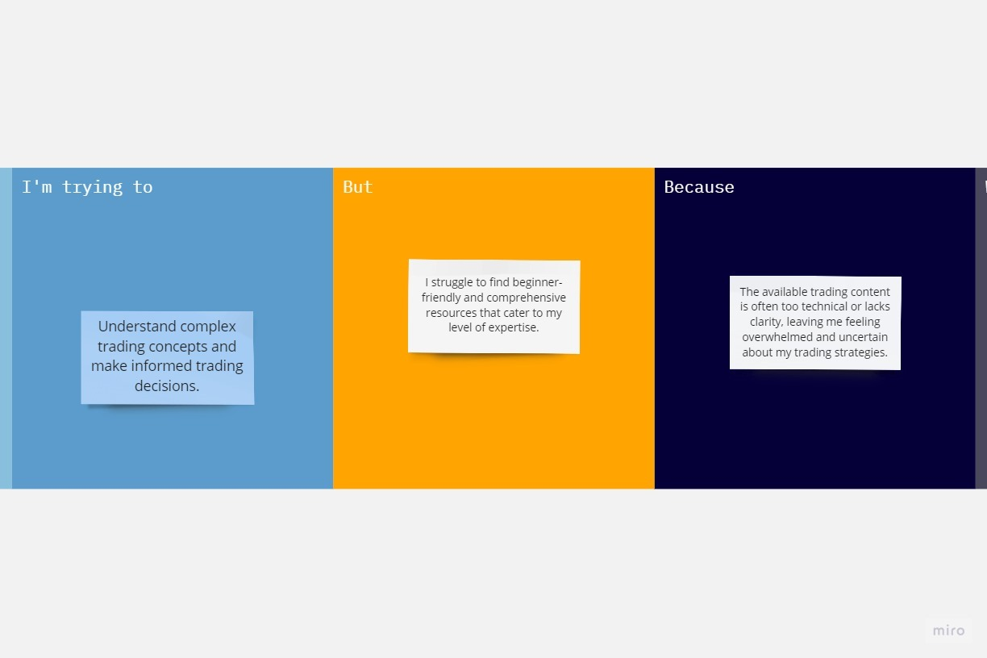

|  |  |  |  |  |  |
| --- | --- | --- | --- | --- | --- |
| **Problem Statement (PS)** | **I am (Customer)** | **I’m trying to** | **But** | **Because** | **Which makes me feel** |
| PS-1 | A novice trader | Understand complex trading concepts and make informed trading decisions | I struggle to find beginner-friendly and comprehensive resources that cater to my level of expertise. | The available trading content is often too technical or lacks clarity, leaving me feeling overwhelmed and uncertain about my trading strategies. | Frustrated and anxious, as I'm unable to gain the knowledge and confidence I need to succeed in the trading world. |

2.1.2 Understanding of the Project:

**Educational Hub:** "Mr. Panakkar" is an educational platform aimed at helping traders of all levels gain a deep understanding of trading, from basics to advanced strategies.

**Market Analysis:** The project offers regular market updates and analysis to keep traders informed about changing market trends and opportunities.

**Supportive Community:** It fosters a vibrant community of traders who can interact, ask questions, and share experiences, creating a supportive learning environment.

**Tools and Resources:** "**Mr. Panakkar**" provides a wide range of resources, including educational content, trading tools, and insights from experienced traders, offering a holistic approach to trading.

**Empowerment:** The project's core objective is to empower traders with the knowledge and skills they need to make confident, informed, and successful trading decisions.

2.2 EMPATHY MAP CANVAS:

An empathy map canvas is a visual tool used in design thinking and customer-centric processes to gain a deeper understanding of the target audience's feelings, thoughts, needs, and experiences. It helps teams to put themselves in the users' shoes and create solutions that truly address their needs and desires.

Target Persona: Prospective or Novice Trader

Says:

* "I want to find a reliable source of information to learn from."
* "Are there any good trading platforms for beginners?"
* "I need to figure out how much money I can risk without endangering my finances."

Thinks:

* "I feel overwhelmed by the amount of information and choices out there."
* "I want to learn and gain confidence in my trading skills."
* "What if I make a wrong decision and lose money? It's a bit scary."

Does:

* Follows and engages with trading experts on social media."
* "Begins paper trading (simulated trading) to gain experience."
* "Sets up a demo trading account to practice without risking real money."
* "Expresses curiosity by asking questions about trading concepts."

Feels:

* Determination: Novice traders can be determined and motivated to overcome challenges and gain proficiency in trading.
* Caution: They may approach trading cautiously, emphasizing risk management and capital preservation.
* Hope: There is hope for achieving financial security and independence through trading.

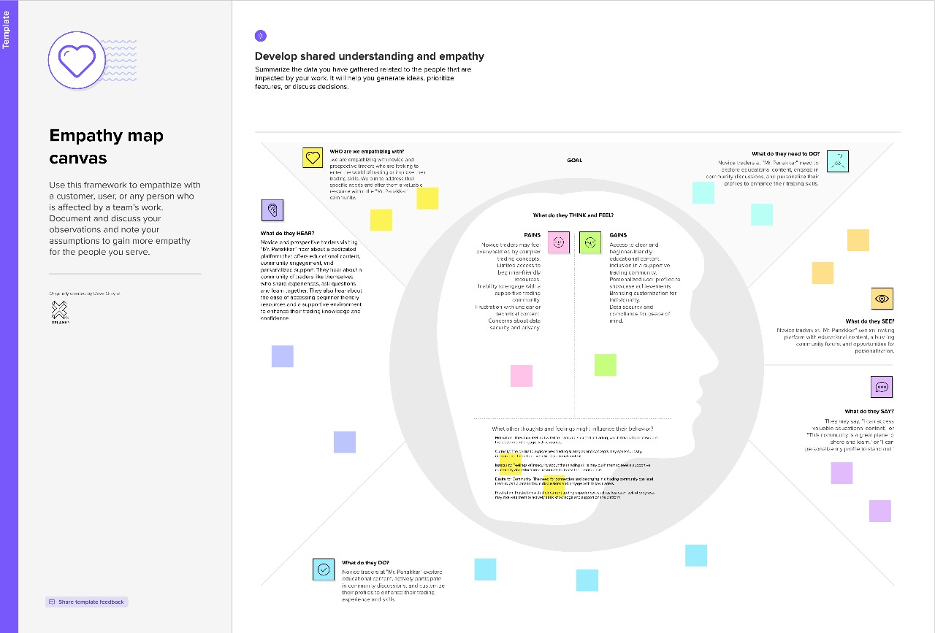

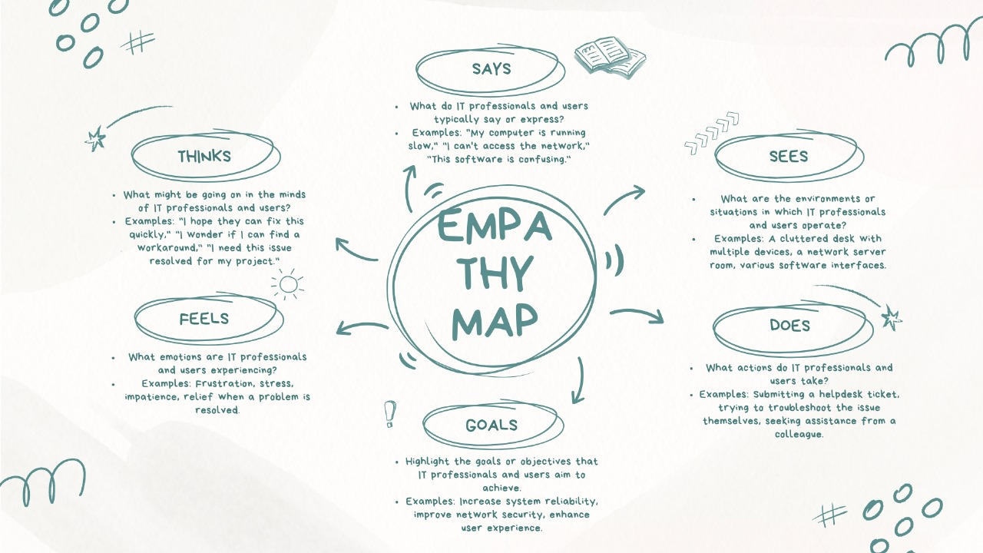

2.3 BRAINSTROMING AND IDEATION PHASE:

Brainstorming provides a free and open environment that encourages everyone within a team to participate in the creative thinking process that leads to problem solving. Prioritizing volume over value, out-of-the-box ideas are welcome and built upon, and all participants are encouraged to collaborate, helping each other develop a rich amount of creative solutions.

Use this template in your own brainstorming sessions so your team can unleash their imagination and start shaping concepts even if you're not sitting in the same room.

Step-1: Team Gathering, Collaboration and Select the Problem statement

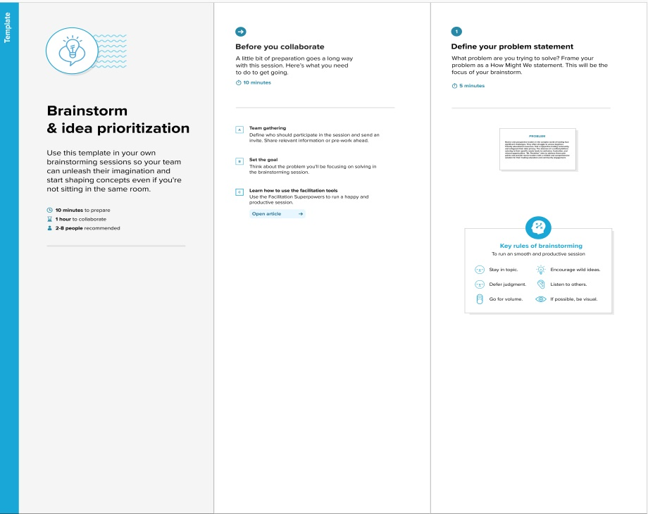

Step-2: Brainstorm, Idea Listing and Grouping

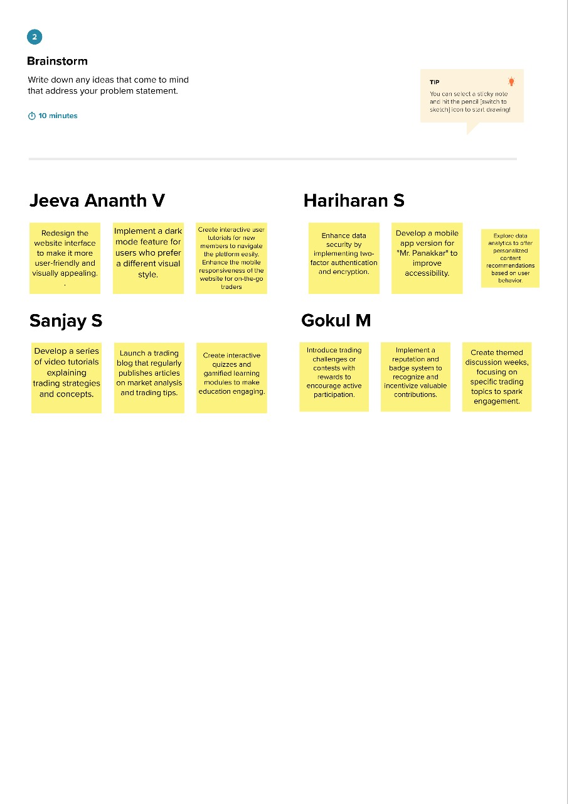

**3. PROJECT FLOW AND ANALYSIS**

In this section, we delve into the structural and analytical aspects of the project, outlining how it functions and what criteria it must meet. It is crucial to establish the project's functional and non-functional requirements to ensure a well-rounded development process.

3.1FUNCTIONAL REQUIREMENTS:

Functional requirements define the specific features and capabilities that a system or project must have to meet its objectives. In the case of the "Mr. Panakkar" project, here are some functional requirements:

**1. User Registration and Profiles:**

- Users can create accounts with profile information.

- Profiles include trading experience level, trading preferences, and goals.

**2. Educational Content:**

- Articles, videos, and webinars on trading basics and strategies.

- Educational content categorized by trading markets (stocks, forex, cryptocurrencies).

- Quizzes and assessments to test trading knowledge.

**3. User Interaction Features:**

- Forum or community for discussions and knowledge sharing.

- Q&A sessions with experienced traders or mentors.

- Live trading simulations for hands-on experience.

**4. Content Delivery:**

- A user-friendly website with easy navigation.

- Regularly updated and organized content.

- Email newsletters to keep users informed about new content and updates.

**5. Community Building:**

- User-generated content sections for trading stories and experiences.

- Challenges or contests to encourage engagement.

- Moderated forums to ensure a positive and informative community.

**6. Engagement Mechanisms:**

- Comment sections on blog posts.

- Interactive elements like polls, surveys, and feedback forms.

- Notifications for new content and community activities.

**7. Analytics and Feedback Tools:**

- Integration with analytics tools to track user behavior and engagement.

- User feedback mechanisms to collect suggestions, questions, and concerns.

**8. Monetization Strategies:**

- Premium content or courses for advanced users.

- Affiliate marketing partnerships with trading platforms.

- Advertising or sponsorships from trading-related companies.

**9. Search and Filter Options:**

- Search bar for users to find specific content.

- Filters to sort content by market, skill level, or topic.

**10. User Support:**

- Contact form or chat support for user inquiries.

- FAQ section for common questions and issues.

**11. Mobile Responsiveness:**

- Ensure the website is mobile-friendly for users on various devices.

**12. Security:**

- Secure user data and payment information (if applicable).

- Implement measures to protect against spam and cyber threats.

**13. Content Management System (CMS):**

- User-friendly CMS for content creators to easily publish and manage content.

|  |  |  |
| --- | --- | --- |
| **FR No.** | **Functional Requirement (Epic)** | **Sub Requirement (Story / Sub-Task)** |
| FR-1 | User Education | Users can access educational content, including articles and videos.  Content should be categorized by trading markets and skill levels.  Users can rate and provide feedback on the content. |
| FR-2 | Community Engagement | Users can participate in discussions on trading topics.  Discussions can be categorized with tags for easy navigation.  Users can create new discussion threads. |
| FR-3 | Branding Customization | Users can upload and set a custom avatar image for their profiles.  Images should adhere to specified size and format requirements. |
| FR-4 | User Interaction | Users can post comments on articles, videos, and discussion threads.  Users can reply to existing comments to facilitate discussions.  Moderation tools are available to manage and moderate user-generated content. |
| FR-5 | Content Management | Moderators can review and moderate user-generated content for compliance with community guidelines.  Content flagged by users should be reviewed and acted upon promptly. |

These functional requirements are essential for the successful development and operation of the "**Mr. Panakkar**" project, ensuring that it effectively caters to the needs of its target audience and provides a valuable and engaging trading resource.

3.2 NON-FUNCTIONAL REQUIREMENTS:

Non-functional requirements describe the attributes and qualities of a system, product, or project, rather than its specific features. They define how well the system should perform, its scalability, security, and other characteristics. Here are some non-functional requirements for the "Mr. Panakkar" project:

**1. Performance:**

- The website should load quickly and respond to user interactions without significant delays.

- It should be capable of handling a high volume of concurrent users, especially during peak times.

**2. Scalability:**

- The project should be designed to scale both vertically (adding resources to a single server) and horizontally (adding more servers) to accommodate a growing user base.

**3. Security:**

- User data and payment information (if applicable) should be encrypted and protected from unauthorized access.

- Measures should be in place to prevent cyber threats, including DDoS attacks and data breaches.

**4.Reliability:**

- The website should be available and operational 24/7 with minimal downtime for maintenance.

- Backup and disaster recovery plans should be in place to ensure data integrity.

**5. Usability:**

- The user interface should be intuitive, with easy navigation and clear content organization.

- The website should be accessible to users with disabilities, following relevant accessibility guidelines.

**6.Compatibility:**

- The project should be compatible with various web browsers, operating systems, and devices, ensuring a consistent user experience.

**7.Compliance:**

- The project should adhere to relevant legal and regulatory requirements, including data protection and copyright laws.

**8.Response Time:**

- Web pages should load within a reasonable time frame, even for users with slower internet connections.

**9.Monitoring and Analytics:**

- Implement monitoring tools to track system performance and user behavior.

- Use analytics data to continuously improve the user experience and content quality.

**10.Data Backup and Recovery:**

- Regularly back up user data and content to prevent data loss.

- Establish recovery procedures to restore the system in case of failure.

**11.Resource Efficiency:**

- Optimize resource usage, such as server capacity and bandwidth, to minimize operational costs.

|  |  |  |
| --- | --- | --- |
| **FR No.** | **Non-Functional Requirement** | **Description** |
| NFR-1 | **Usability** | The website should be user-friendly and intuitive, with a straightforward and clear interface. |
| NFR-2 | **Security** | User data and interactions should be secure and protected from unauthorized access or data breaches. |
| NFR-3 | **Reliability** | The website should be available and functional 24/7 with minimal downtime. |
| NFR-4 | **Performance** | The website should load and respond quickly to user interactions, ensuring a smooth and responsive user experience. |
| NFR-5 | **Availability** | This software can remain operational even in the event of software and hardware failure. |
| NFR-6 | **Scalability** | The website should be able to handle a growing user base and increasing data without performance degradation. |

**4.PROJECT DESIGN**

Designing the "Mr. Panakkar" project involves creating a blueprint for the website and its components. Here's a high-level overview of the project design:

* 1. USER – CENTRIC NAVIGATION DESIGN:

User-centric navigation design is a critical aspect of the "Mr. Panakkar" project to ensure that users can easily find, access, and interact with the content and features. Here are some key considerations for user-centric navigation design:

**1. Clear and Intuitive Menus:**

Implement a clear and concise menu structure that categorizes content logically.

Use straightforward and descriptive labels for menu items.

**2. User-Centered Labels:**

Choose labels that resonate with the target audience and match their expectations.

Use terms and language that novice and prospective traders understand.

**3. Consistency:**

Maintain consistency in menu placement and structure across all pages of the website.

Ensure that users can predict where to find specific content or features.

**4. Responsive Design:**

Ensure that navigation elements adapt to different screen sizes and devices for a seamless user experience.

Implement a mobile-friendly menu for users on smartphones and tablets.

**5. Prioritization of Content:**

Highlight the most important and frequently accessed content or features prominently in the navigation menu.

Use visual cues like icons or color to draw attention to key items.

**6. User Feedback and Testing:**

Gather user feedback on the navigation design through surveys, usability testing, or feedback forms.

Use this feedback to make improvements and refinements.

**7. Search Functionality:**

Implement an effective search bar that allows users to quickly find specific content.

Ensure that search results are accurate and relevant.

**8. Filtering and Sorting:**

Provide filter options to help users sort content based on trading markets, skill levels, or topics.

Make it easy for users to find content that matches their interests.

**9. Community Interaction:**

Make community forums and user profiles easily accessible from the main menu.

Encourage user interaction and discussions within the community.

**10. Accessibility:**

- Ensure that the navigation is accessible to users with disabilities, following relevant accessibility guidelines.

- Provide alternative navigation options for users who may have difficulty using traditional menus.

**11. Error Handling:**

- Design user-friendly error pages and messages to guide users when they encounter navigation errors.

- Offer clear instructions on what to do next.

**12. User Education:**

- Include brief tutorials or tooltips for new users to guide them in using the navigation effectively.

- Offer links to resources that explain how to navigate the site.

User-centric navigation design should prioritize the ease of use, accessibility, and satisfaction of the website's visitors. It should be continually evaluated and refined based on user feedback and evolving user needs.

4.2 BRANDING CUSTOMIZATION AND BRANDING:

* Visual Branding:

Visual branding is a fundamental component of a company's or project's brand identity. It encompasses the visual elements and design choices that shape how the brand is perceived by the audience. The logo is attached below.



* 1. RESPONSIVE DESIGN:

Responsive design is a critical aspect of web and app development, ensuring that digital platforms adapt and function optimally on various screen sizes and devices. It involves creating layouts, content, and interactions that provide a consistent and user-friendly experience, regardless of the user's device. Responsive design accounts for the fact that users access websites and apps on a wide range of devices, including desktop computers, laptops, tablets, and smartphones. The goal is to make the platform look and work well on all of them.

DESKTOP VIEW OF THE WEBSITE:

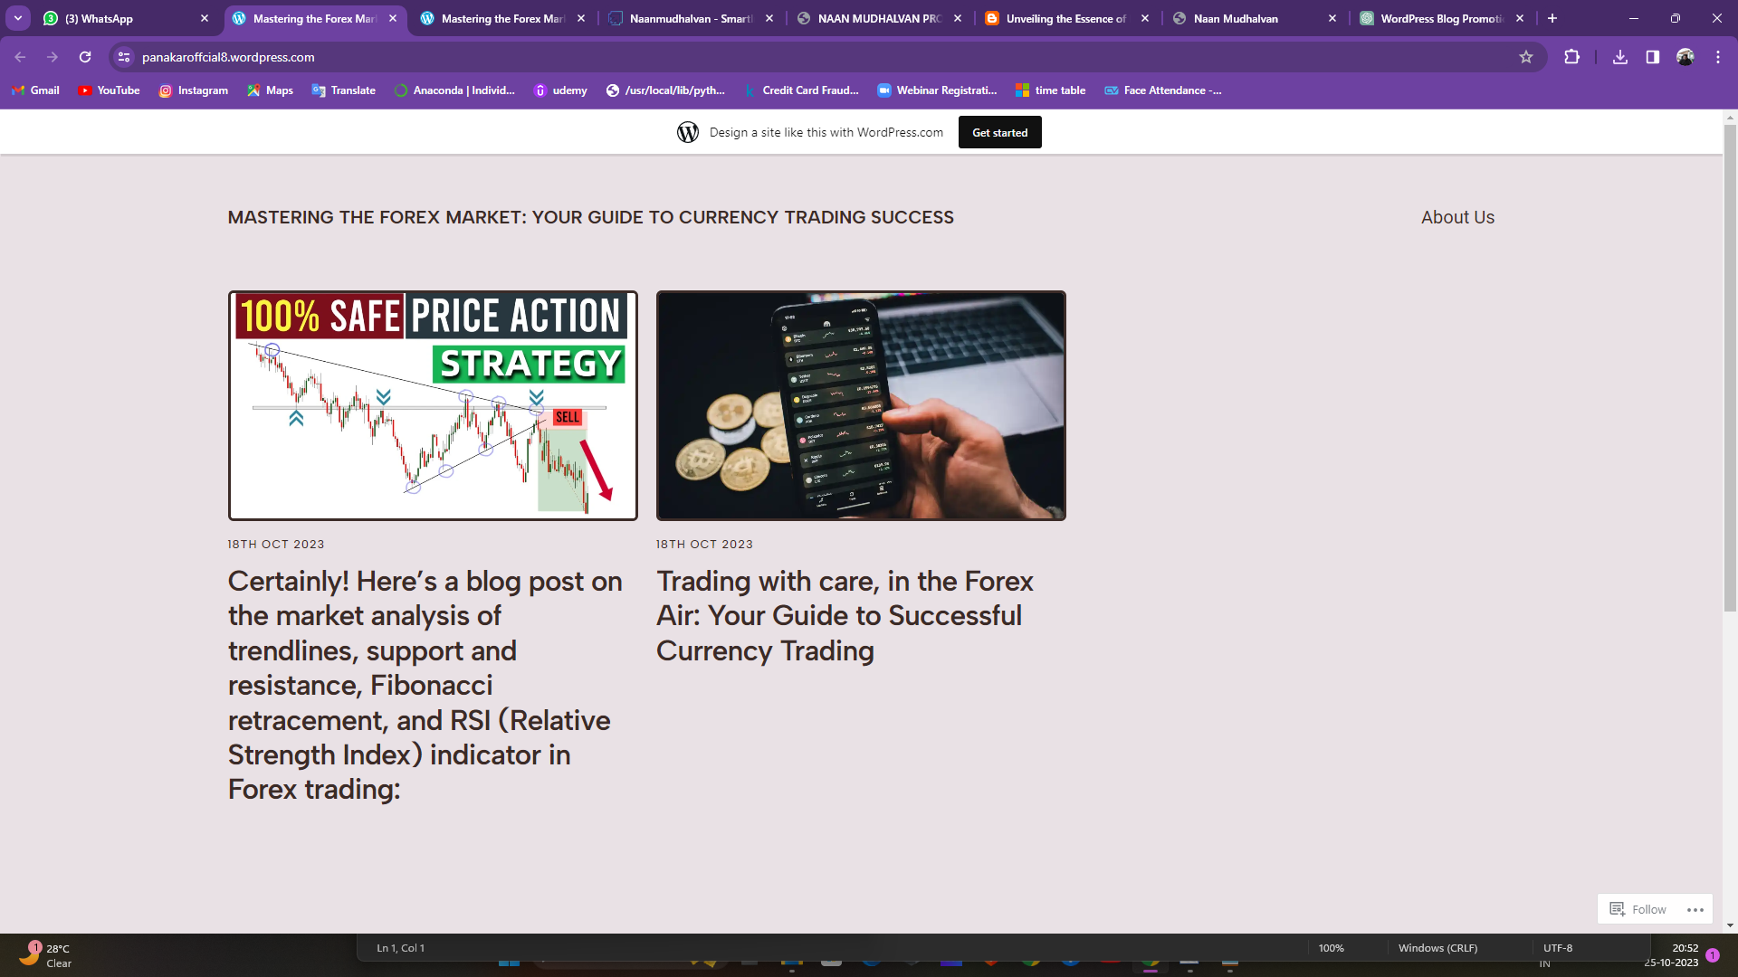

MOBILE VIEW OF THE WEBSITE:

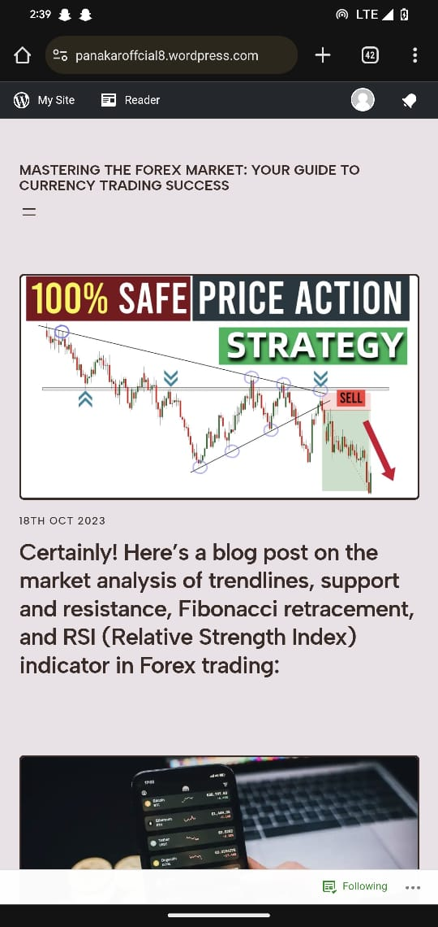

**6.IMPLEMENTATION PLAN**

In this section, we provide a step-by-step guide to creating a website for a book cafe using Canva.

**Step 1: Navigate to Wordpress and sign in**

Navigate to Wordpress and sign in or create a new account that is created for your brand.

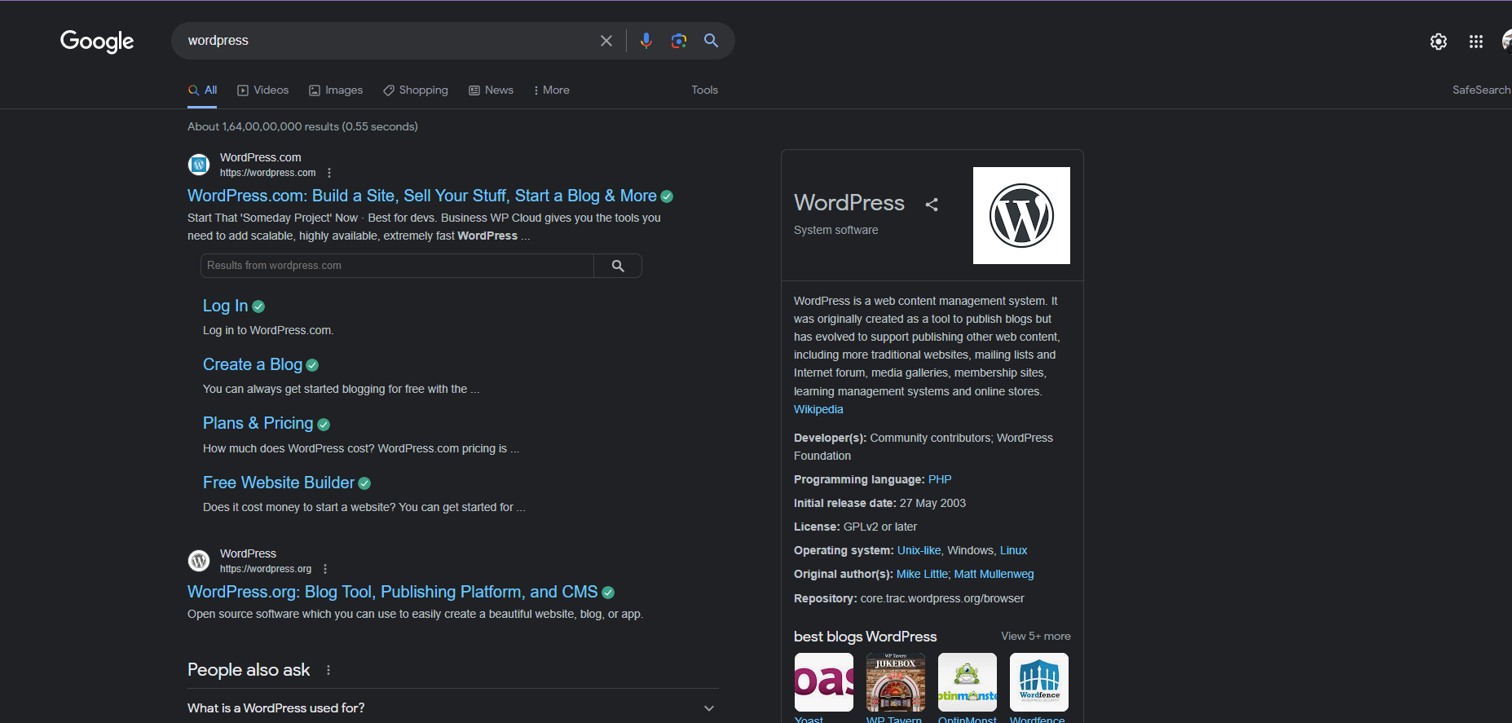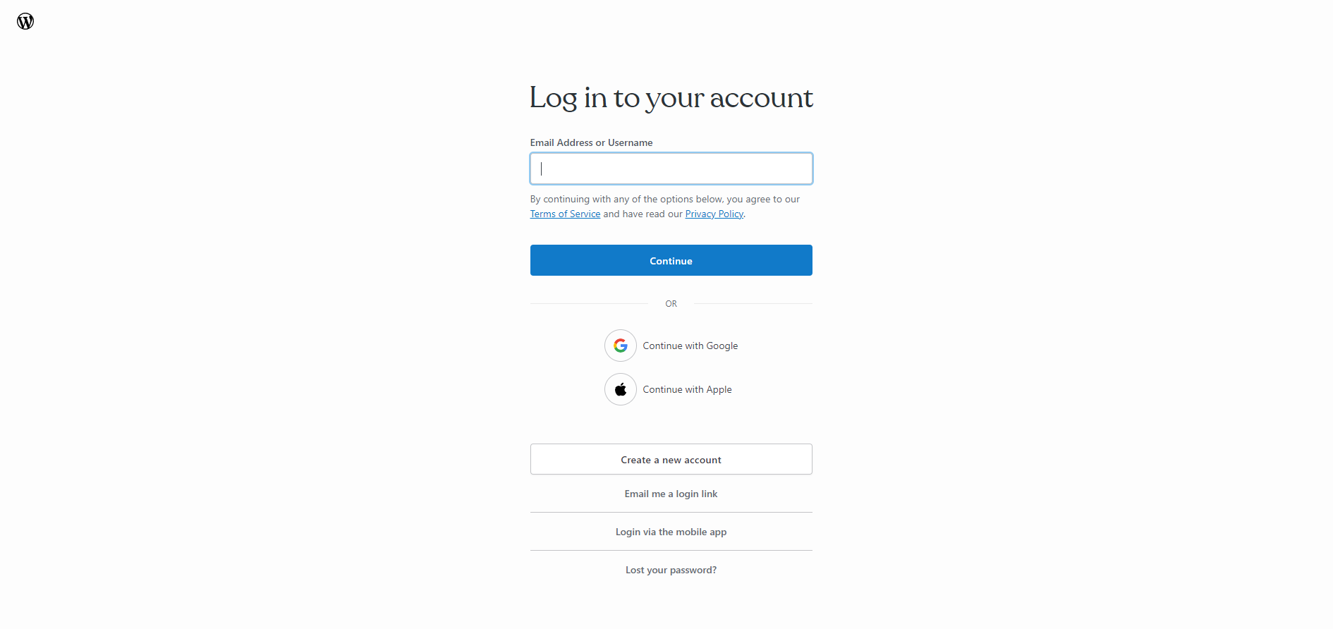

**Step 2: Click the Create account**

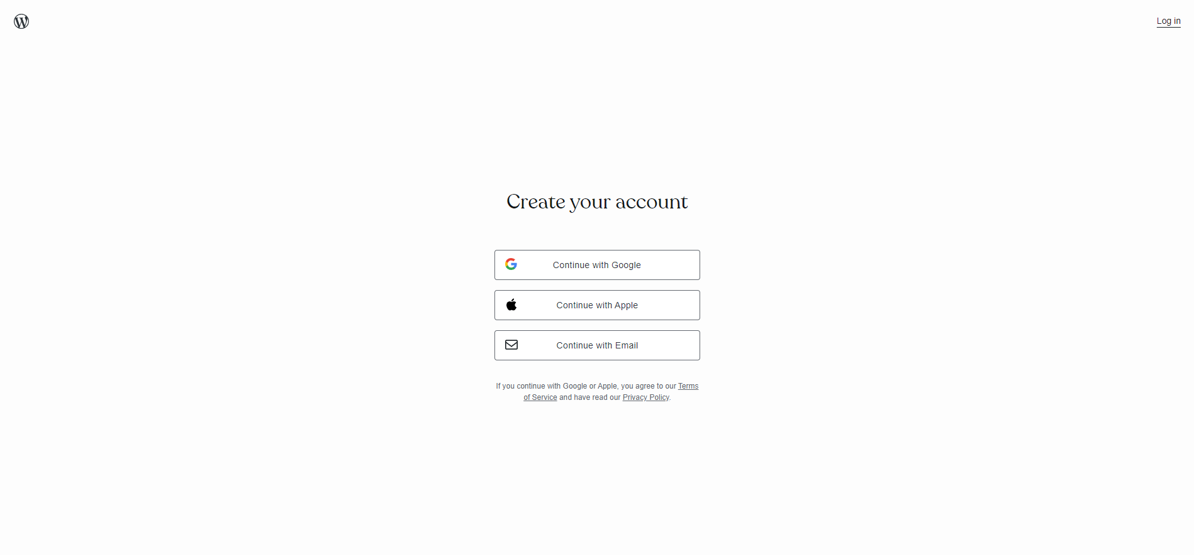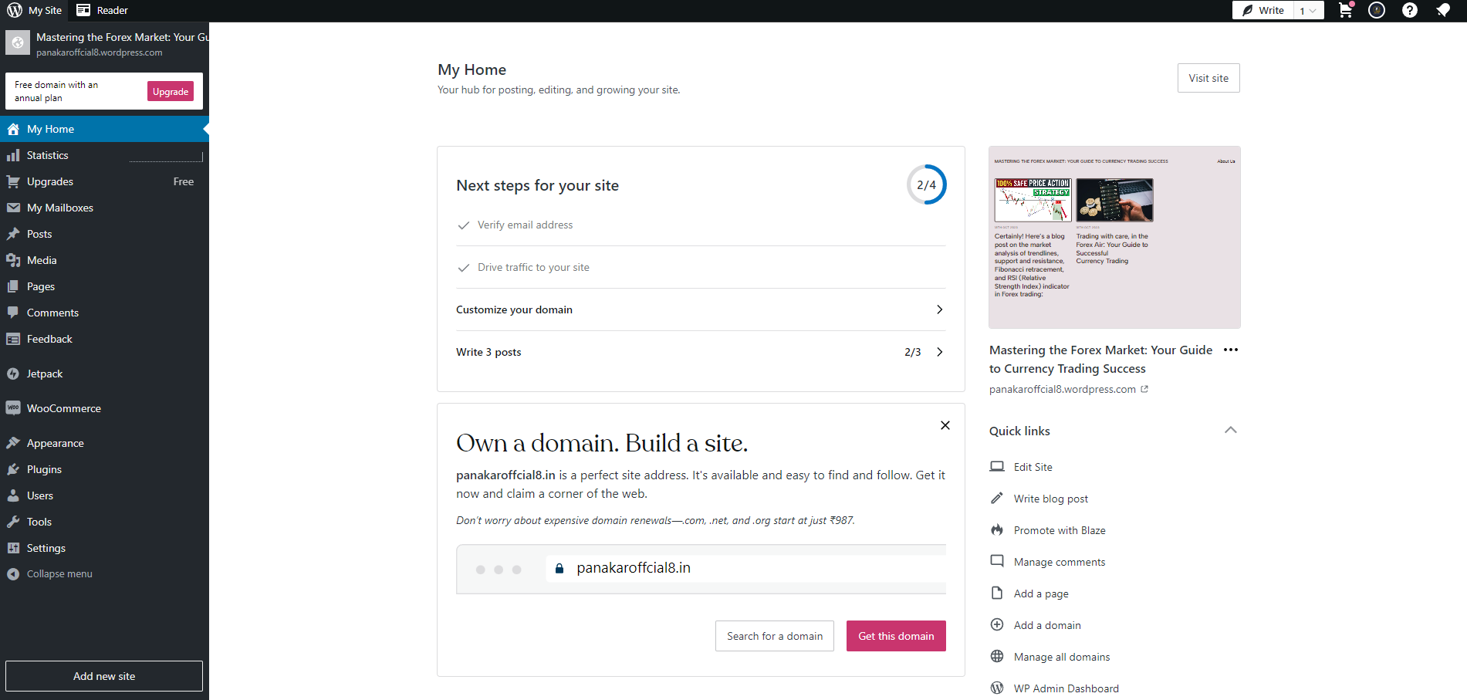

**Step 3: Type the content and click the create the blogspot.**

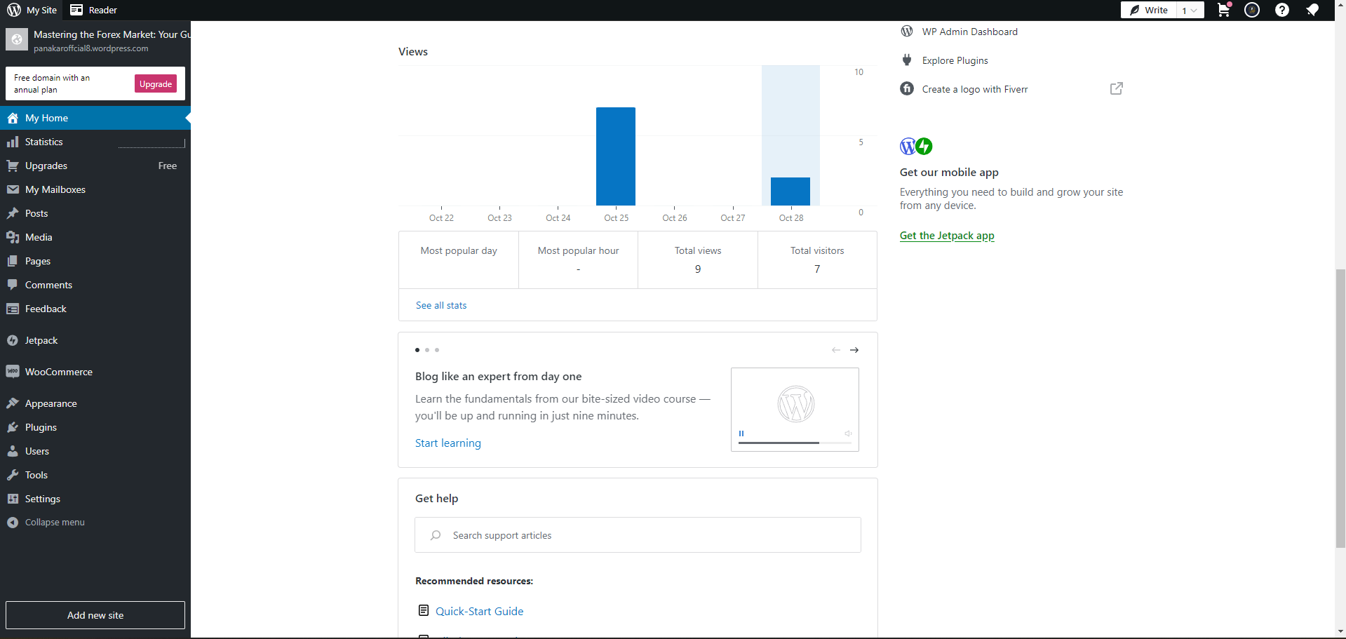

**Step 4: Type the content and publish the first post.**

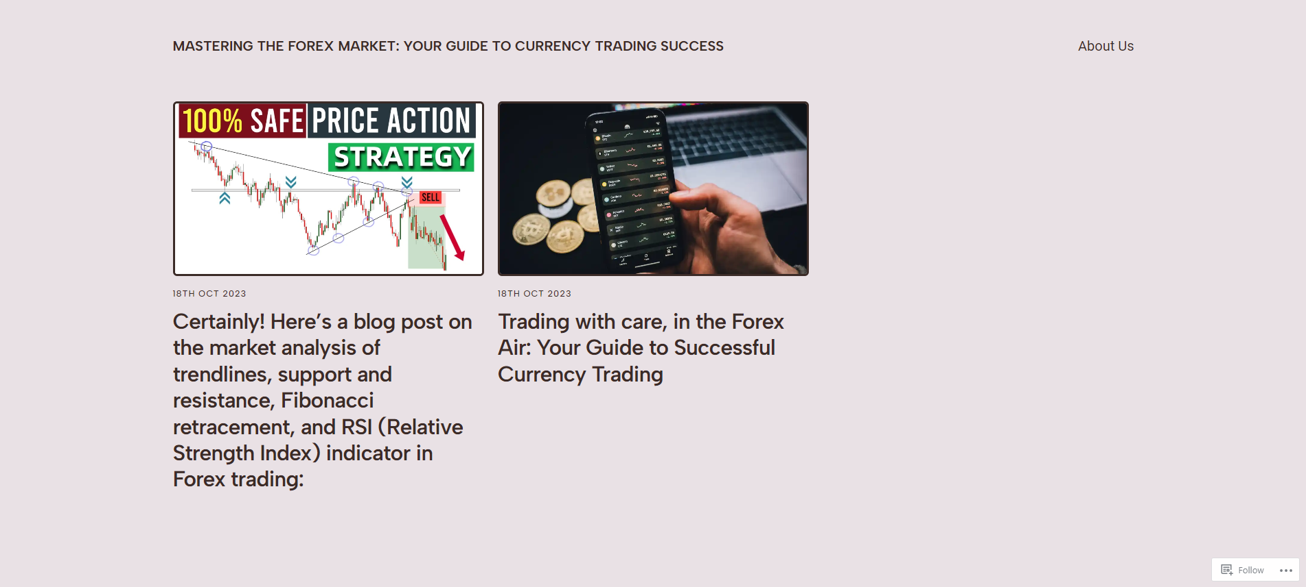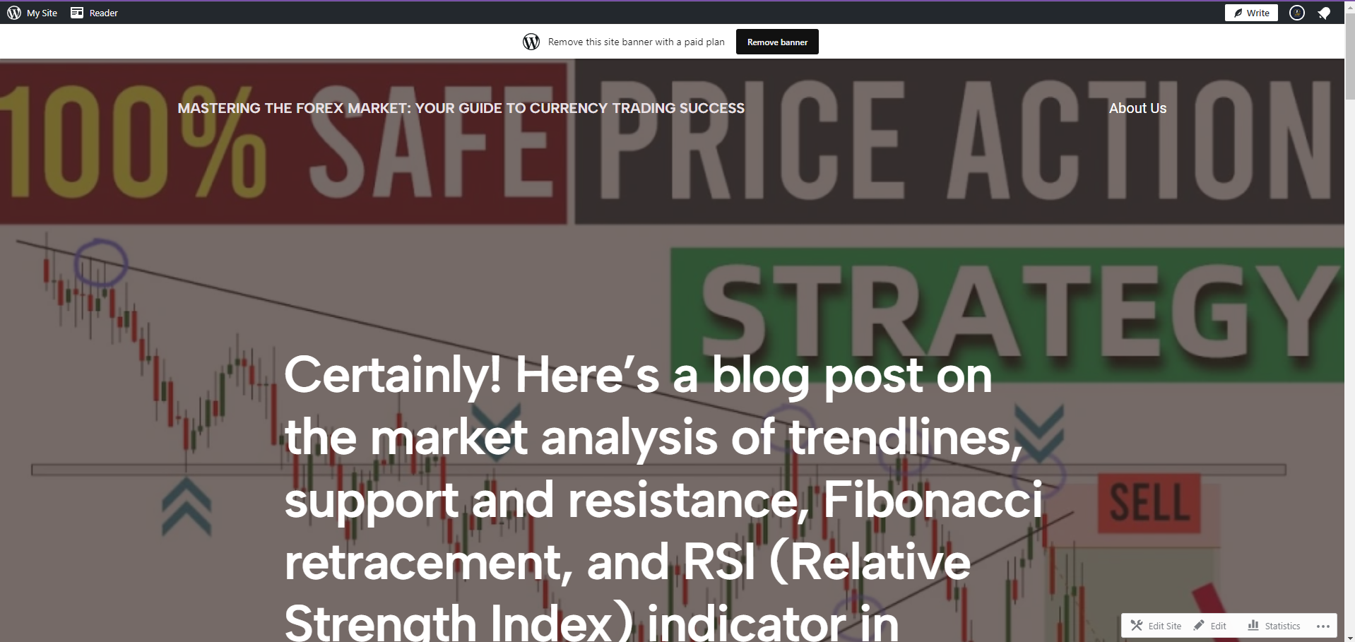

**7. RESULT AND ANALYSIS**

The "Mr. Panakkar" project, with its user-centric navigation and branding customization, aims to provide a highly engaging and personalized experience for novice and prospective traders. Let's look at the expected results and potential analysis of these aspects:

**1. Improved User Engagement:** A clear and intuitive navigation design will lead to increased user engagement as visitors can easily access the content and features they're interested in.

**2. Reduced Bounce Rate:**  An effective navigation system can lower the bounce rate, as users are more likely to explore multiple pages and spend more time on the site.

**3. Enhanced User Satisfaction:** Users will appreciate the ease of finding relevant content and interacting with the community, leading to higher satisfaction levels.

**4. Better Conversion Rates:** Intuitive navigation can drive more users to take desired actions, such as signing up for the community, subscribing to newsletters, or accessing premium content.

**Analysis:**

**1.User Behavior Tracking:** Use analytics tools to monitor how users navigate the site, identifying popular pathways and areas with drop-offs or high interaction.

**2. Usability Testing:** Conduct usability tests with a sample of novice traders to gather feedback on the navigation's effectiveness and make improvements accordingly.

**3. Feedback Collection:**  Continuously gather user feedback on the navigation design through surveys, feedback forms, or community discussions.

**4. Performance Metrics:** Track metrics such as page views, time spent on site, and click-through rates to assess the impact of the navigation design.

**Expected Results:**

**1. Strong Brand Identity:** A well-defined logo, color palette, and typography will create a strong and recognizable brand identity for "Mr. Panakkar."

**2. Professional Image:** The professional and trustworthy design elements will instill confidence in users, especially those new to trading.

**3. Memorable Slogan:** A memorable slogan or tagline can help users associate the project with its purpose and benefits.

**4. User Engagement:** Branding customization features, such as personalized profiles and community emblems, can enhance user engagement and foster a sense of belonging.

**Analysis:**

**1. Brand Recognition:** Monitor brand recognition through user surveys or tracking how often users share or refer to the project.

**2.User-Generated Content:** Analyze the impact of user-generated content on the brand's visual identity and engagement levels.

**3.User Personalization:** Assess the usage of branding customization features by users to understand their preferences and level of engagement.

**4. Feedback and Surveys:** Collect user feedback on the branding and customization aspects to identify areas for improvement and alignment with user expectations.

The project should continuously analyze and adapt its user-centric navigation design and branding to align with user preferences and feedback, aiming to create an inviting and personalized trading resource for novice and prospective traders.

**8. RECOMMENDATION FOR THE FUTURE**

The "Mr. Panakkar" project, with its user-centric navigation and branding customization, aims to provide a highly engaging and personalized experience for novice and prospective traders. Let's look at the expected results and potential analysis of these aspects:

User-Centric Navigation Design:

Expected Results:

1. Improved User Engagement: A clear and intuitive navigation design will lead to increased user engagement as visitors can easily access the content and features they're interested in.

2. Reduced Bounce Rate: An effective navigation system can lower the bounce rate, as users are more likely to explore multiple pages and spend more time on the site.

3. Enhanced User Satisfaction: Users will appreciate the ease of finding relevant content and interacting with the community, leading to higher satisfaction levels.

4. Better Conversion Rates: Intuitive navigation can drive more users to take desired actions, such as signing up for the community, subscribing to newsletters, or accessing premium content.

Analysis:

1. User Behavior Tracking: Use analytics tools to monitor how users navigate the site, identifying popular pathways and areas with drop-offs or high interaction.

2. Usability Testing: Conduct usability tests with a sample of novice traders to gather feedback on the navigation's effectiveness and make improvements accordingly.

3. Feedback Collection: Continuously gather user feedback on the navigation design through surveys, feedback forms, or community discussions.

4. Performance Metrics: Track metrics such as page views, time spent on site, and click-through rates to assess the impact of the navigation design.

Branding and Branding Customization:

Expected Results:

1. Strong Brand Identity: A well-defined logo, color palette, and typography will create a strong and recognizable brand identity for "Mr. Panakkar."

2. Professional Image: The professional and trustworthy design elements will instill confidence in users, especially those new to trading.

3. Memorable Slogan: A memorable slogan or tagline can help users associate the project with its purpose and benefits.

4. User Engagement: Branding customization features, such as personalized profiles and community emblems, can enhance user engagement and foster a sense of belonging.

Analysis:

1. Brand Recognition: Monitor brand recognition through user surveys or tracking how often users share or refer to the project.

2. User-Generated Content: Analyze the impact of user-generated content on the brand's visual identity and engagement levels.

3. User Personalization: Assess the usage of branding customization features by users to understand their preferences and level of engagement.

4. Feedback and Surveys: Collect user feedback on the branding and customization aspects to identify areas for improvement and alignment with user expectations.

The project should continuously analyze and adapt its user-centric navigation design and branding to align with user preferences and feedback, aiming to create an inviting and personalized trading resource for novice and prospective traders.

**9. SCOPE OF THE PROJECT**

The scope of the "Mr. Panakkar" project encompasses various components and objectives that collectively aim to provide a comprehensive and user-centric trading resource. Here's an overview of the project's scope:

1. Educational Content:

- The project will offer a wide range of educational content, including articles, videos, webinars, and interactive materials that cover trading basics, strategies, and market analysis.

2. User Community:

- The website will include a user community forum where novice and prospective traders can engage in discussions, share experiences, and seek advice from peers and experts.

3. Personalized User Profiles:

- Users can create personalized profiles, highlighting their trading experience, interests, and achievements within the trading community.

4. Branding and Visual Identity:

- The project will establish a strong and recognizable branding, incorporating a unique logo, color palette, typography, and a memorable slogan or tagline.

5. Branding Customization:

- Users will have the ability to customize their profiles, including avatars, cover images, and community badges.

6. Mobile Responsiveness:

- The website will be designed to ensure a seamless and user-friendly experience on various devices, including smartphones and tablets.

7. Monetization Strategies:

- The project may incorporate monetization strategies, such as premium content access, affiliate marketing partnerships, or advertising/sponsorship opportunities.

8. Data Analytics and Feedback Mechanisms:

- Advanced data analytics tools will be utilized to monitor user behavior and content performance.

- Continuous feedback mechanisms, including surveys, usability testing, and user-generated content, will be used to gather user insights and improve the project.

9. Compliance and Security:

- The project will adhere to legal and regulatory requirements, particularly in data protection and copyright.

- Security measures will be implemented to safeguard user data and protect against cyber threats.

10. User Support:

- User support will be provided through contact forms, chat support, and FAQ sections to assist users with inquiries and technical issues.

11. Marketing and Outreach:

- A marketing strategy will be developed to expand the project's reach, leveraging social media, email newsletters, and potential partnerships.

12. Content Management System (CMS):

- The project will be built on a user-friendly CMS for easy content creation, publication, and management.

13. Future Expansion:

- The project's scope allows for future expansion and the introduction of advanced features, such as machine learning-driven personalization and global outreach.

The scope of the "Mr. Panakkar" project is comprehensive, aiming to empower novice and prospective traders with knowledge, tools, and a supportive community. It focuses on enhancing the trading experience while maintaining a strong brand identity and personalized user engagement.

**10. CONCLUSION**

In conclusion, the "Mr. Panakkar" project is poised to become a valuable and user-centric resource for novice and prospective traders in the complex world of financial markets. With a clear scope encompassing educational content, user community engagement, branding, and customization features, the project seeks to address the diverse needs and preferences of traders embarking on their trading journey.

By offering a wealth of educational materials, including articles, videos, and webinars, "Mr. Panakkar" aims to demystify trading concepts, provide practical strategies, and equip users with the knowledge required to make informed trading decisions. The user community forum fosters interaction, knowledge sharing, and mentorship opportunities, creating a vibrant and supportive trading community.

The project's strong branding and visual identity, combined with branding customization features, not only convey professionalism and trustworthiness but also offer users a personalized and engaging experience. The mobile responsiveness ensures that trading resources are accessible on various devices, and monetization strategies allow for sustainable growth and value generation.

Furthermore, "Mr. Panakkar" recognizes the importance of data analytics and user feedback, using them as a foundation for continuous improvement and adaptation to user preferences and emerging market trends. Compliance and security measures guarantee the safety of user data and maintain the project's integrity.

The project's scope is flexible, accommodating future expansion and the incorporation of advanced features to provide even more personalized and cutting-edge services.

Ultimately, "Mr. Panakkar" aspires to be a beacon of guidance, education, and support in the world of trading, catering to the evolving needs of novice and prospective traders. It aims to empower individuals to make informed trading decisions, achieve their financial goals, and participate in a thriving and engaged trading community. The journey has begun, and as it continues to evolve, "Mr. Panakkar" remains committed to its mission of fostering trading success and financial empowerment.

**11.APPENDIX**

GITHUB LINK AND DEMO VIDEO LINK

**GITHUB LINK:**

[**https://github.com/JeevaAnanthV/Digital-marketing/tree/main**](https://github.com/JeevaAnanthV/Digital-marketing/tree/main)

**DEMO VEDIO LINK:**

[**https://youtu.be/ZfpBAYS8b0M?si=oYMwtnAztWAWd9_g**](https://youtu.be/ZfpBAYS8b0M?si=oYMwtnAztWAWd9_g)